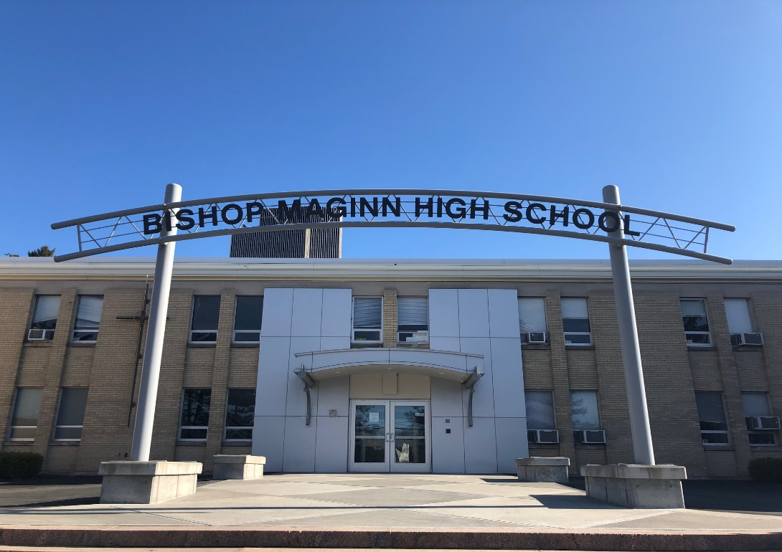

MINIMUM CAPACITY :-

The Minumum intake capacity

of students is between 300-420

children

LIBRARY :-

The Libarary is Available.

CANTEEN:-

The Canteen Facility is Available.

BOARDING :-

No availablility of boarding.

SPORTS :-

There are different categories

sports available.

Girls Volleyball

Boys Volleyball

Football

|  |  |  |
| --- | --- | --- |
| BISHOP MAGINN HIGH SCHOOL  ALBANY - SCHOOL |  |  |
|  |  |  |
| School Detail :- Bishop Maginn High School is a Diocesan Catholic High School staffed by professional and dedicated laity with the goal of preparing students, both morally and academically, for the rigors of undergraduate study.  Bishop Maginn High School is a Diocesan Catholic High School staffed by professional and dedicated laity with the goal of preparing students, both morally and academically, for the rigors of undergraduate study. Maginn serves the youth of the Albany Diocese in grades 9-12. While the majority of the students reside in the City of Albany, approximately 30% reside in 44 different school districts outside of Albany. It is a high school that maintains a solid reputation within the community. As a school with high academic standards and achievements, our curriculum prepares students for educational and professional pursuits. |  |
|